A Sentiment-Aware Feature Rating Framework Using Customer Reviews and Voting Patterns

In this project we have created two users such as Admin and User who can perform following operations
- Admin: admin can login to system using username and password as ‘admin and admin’. After login admin can add new products, remove existing products, view reviews from users and perform ratings analysis of all products
- User: user can sign up and login to system and then search for products and can give reviews and ratings based on features and can view all existing reviews.
To run project install MYSQL database and then open MYSQL console and then copy content from database.txt and paste in MYSQL console to create database. Install python 3.7.2 and then copy content from requirements.txt file and paste in command prompt to install all packages.
SCREEN SHOTS
Now double click on run.bat file to start python web server and get below page
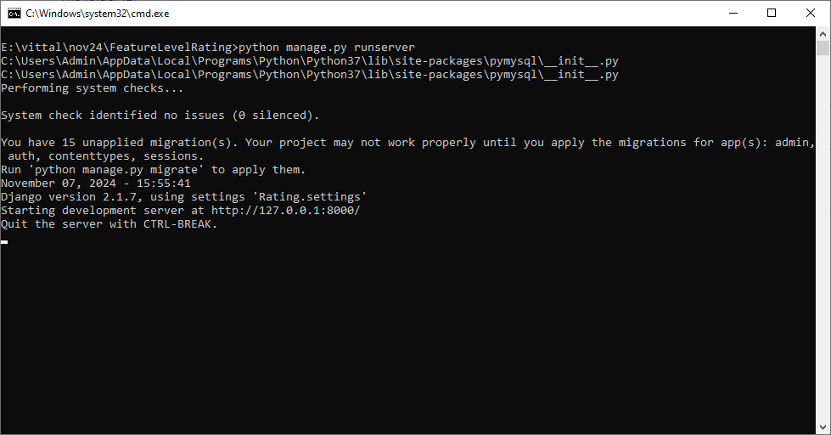
In above screen python server started and now open browser and enter URL as http://127.0.0.1:8000/index.html and then press enter key to get below page
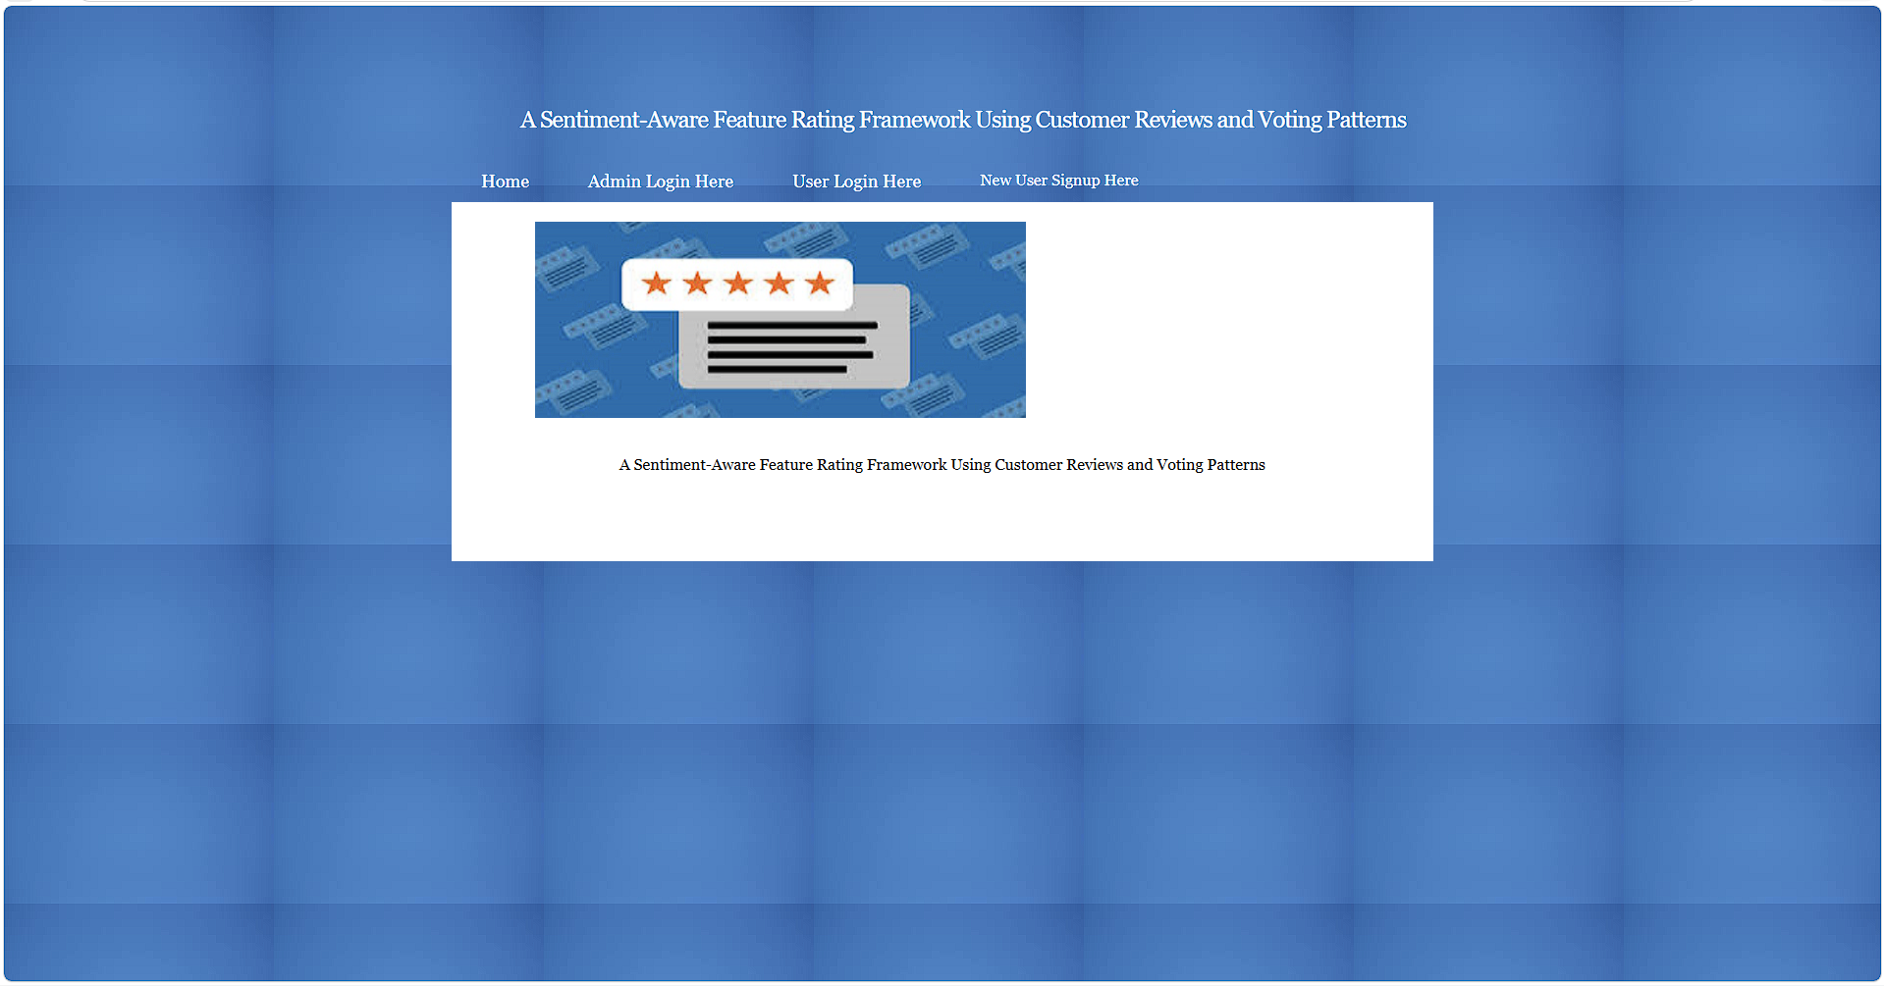
In above screen click on ‘Admin Login’ link to get below page
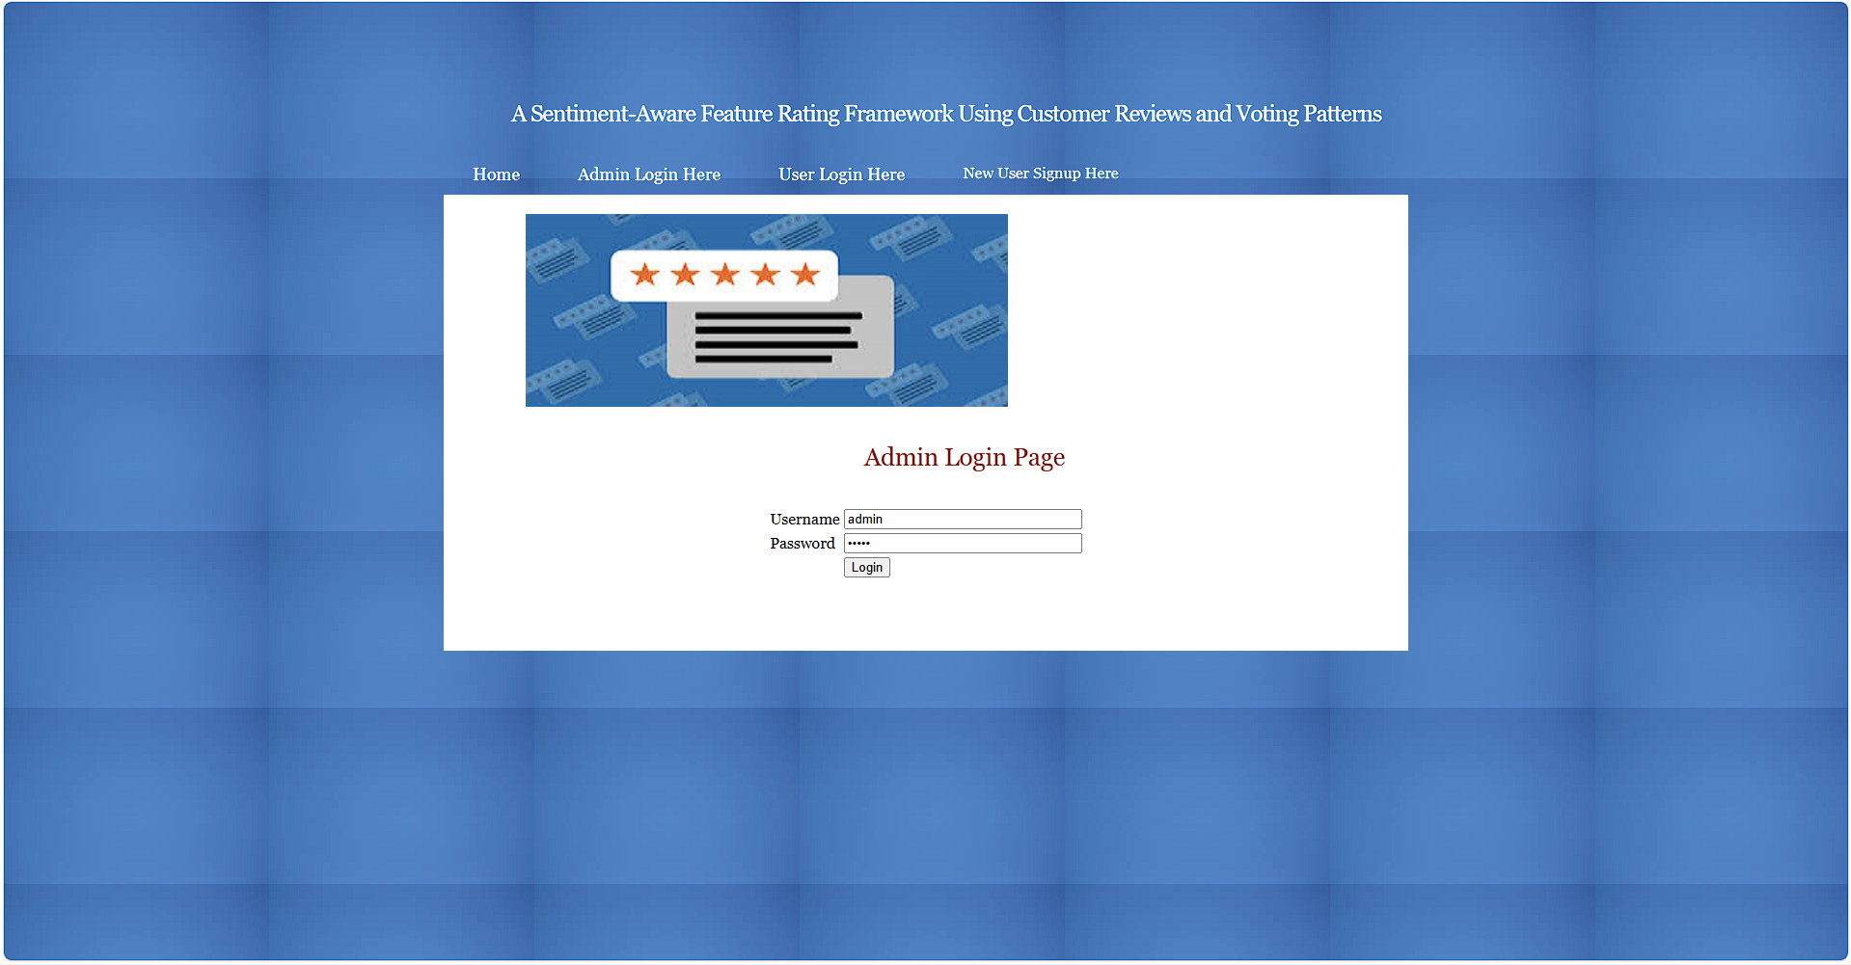
In above screen admin is login and after login will get below page
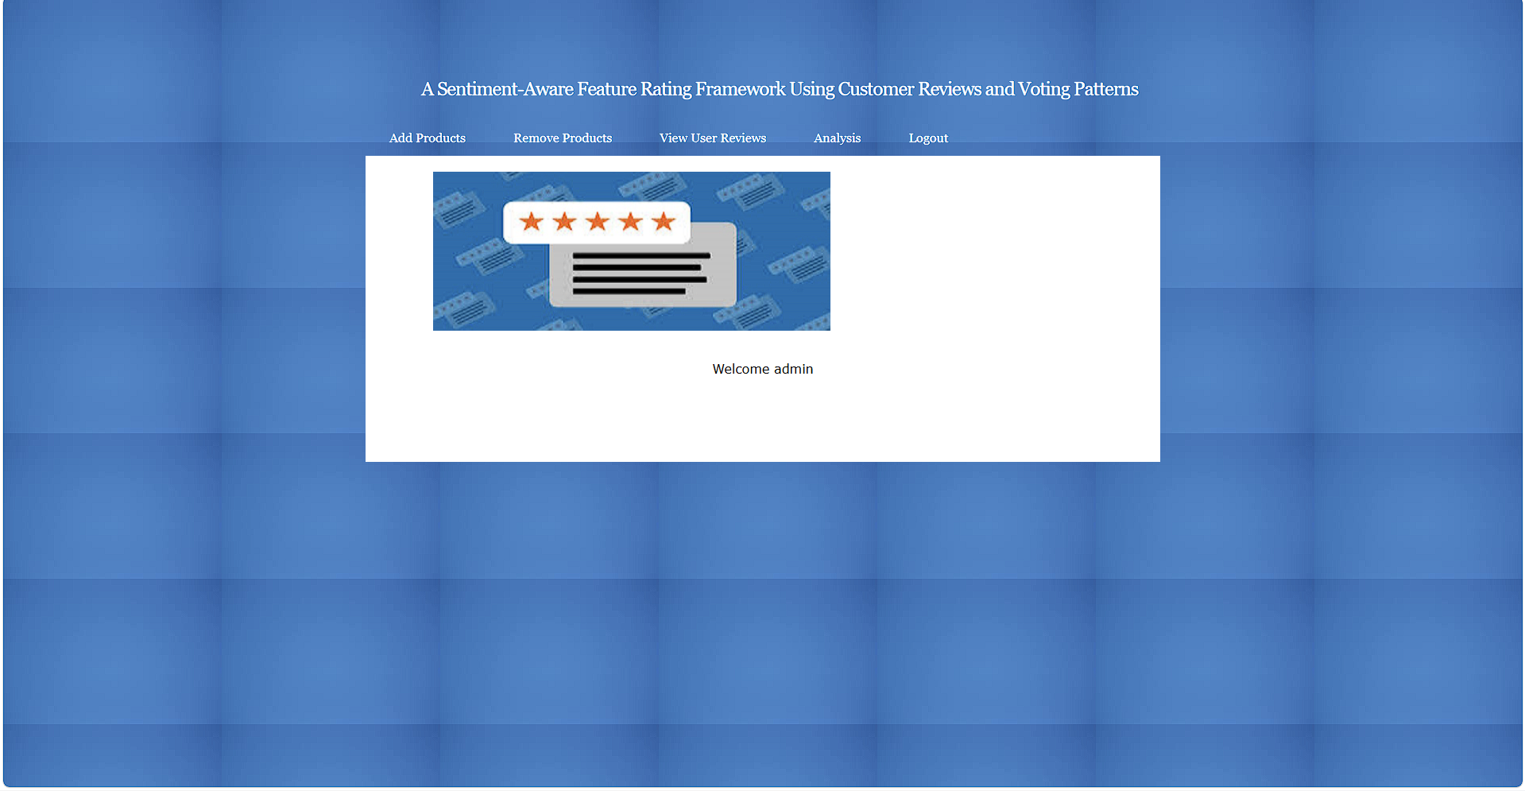
In above screen click on ‘Add Product’ link to get below page
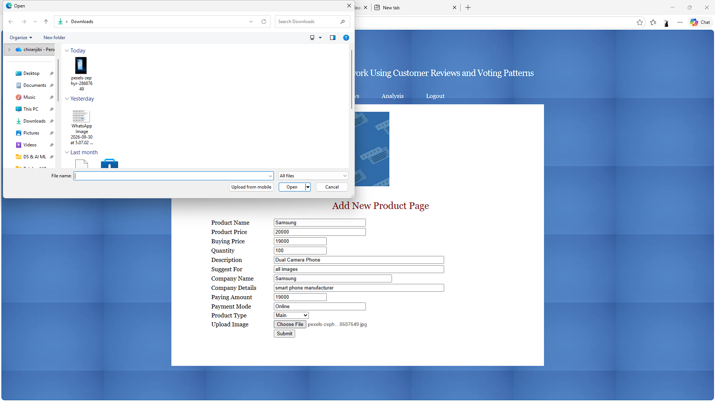
In above screen enter product details and then press button to get below page
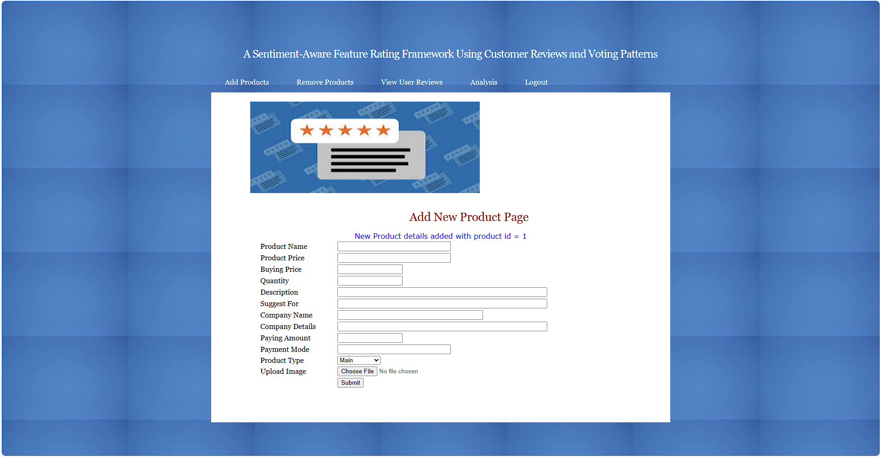
In above screen products details added and now logout and sign up new user
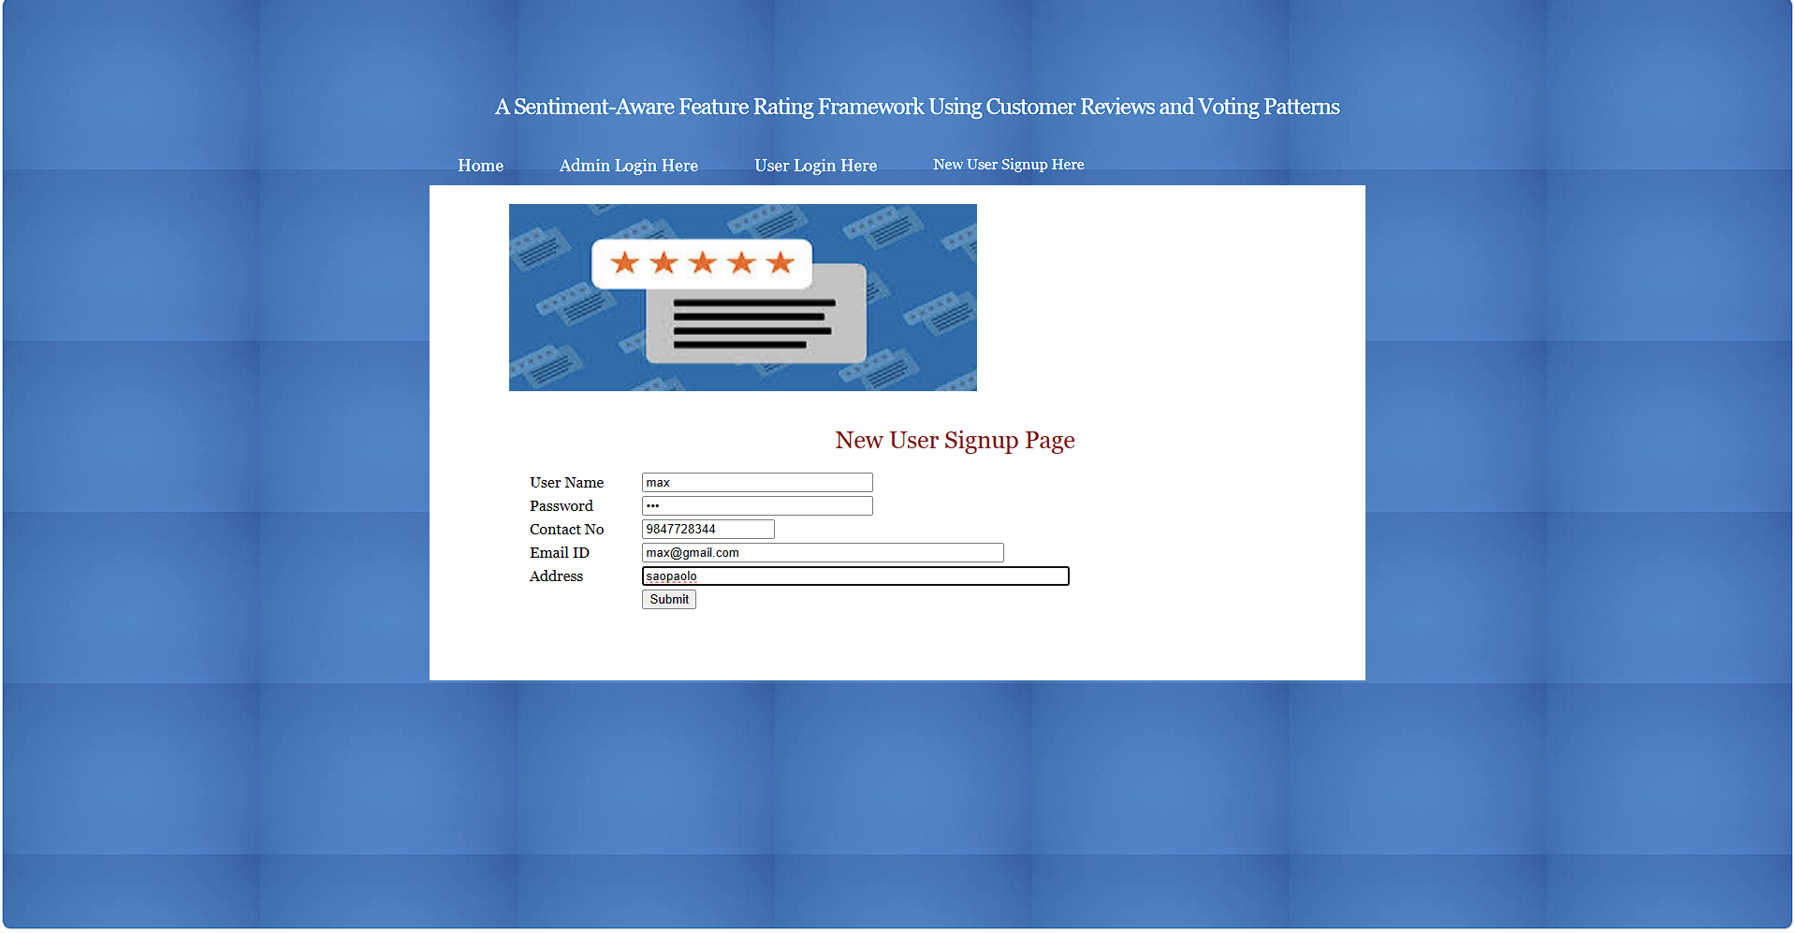
In above screen user is entering signup details and then press button to get below page
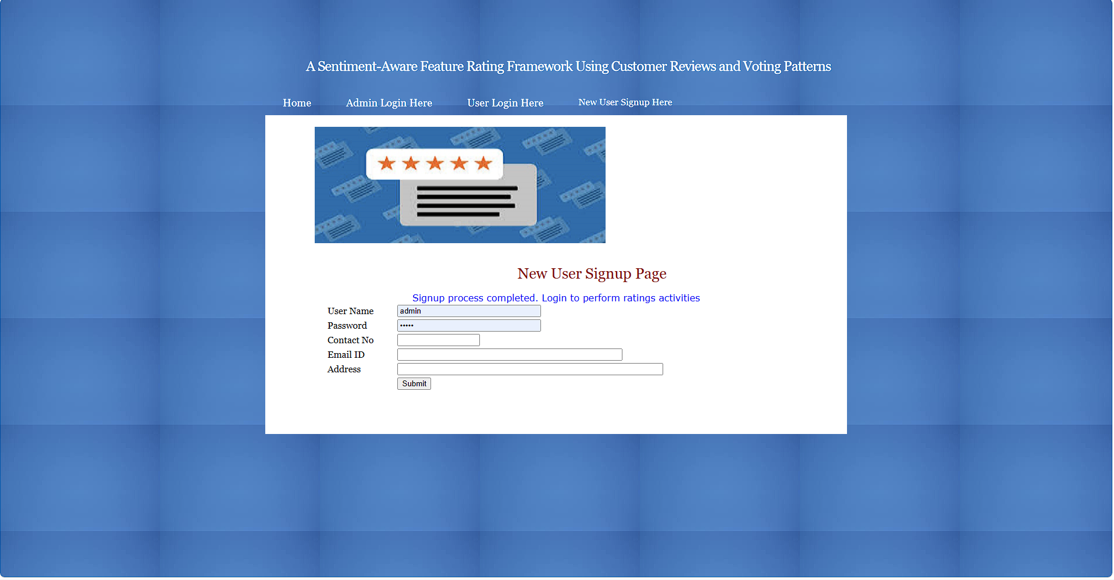
In above screen user sign up completed and now click on ‘User Login’ link to get below page
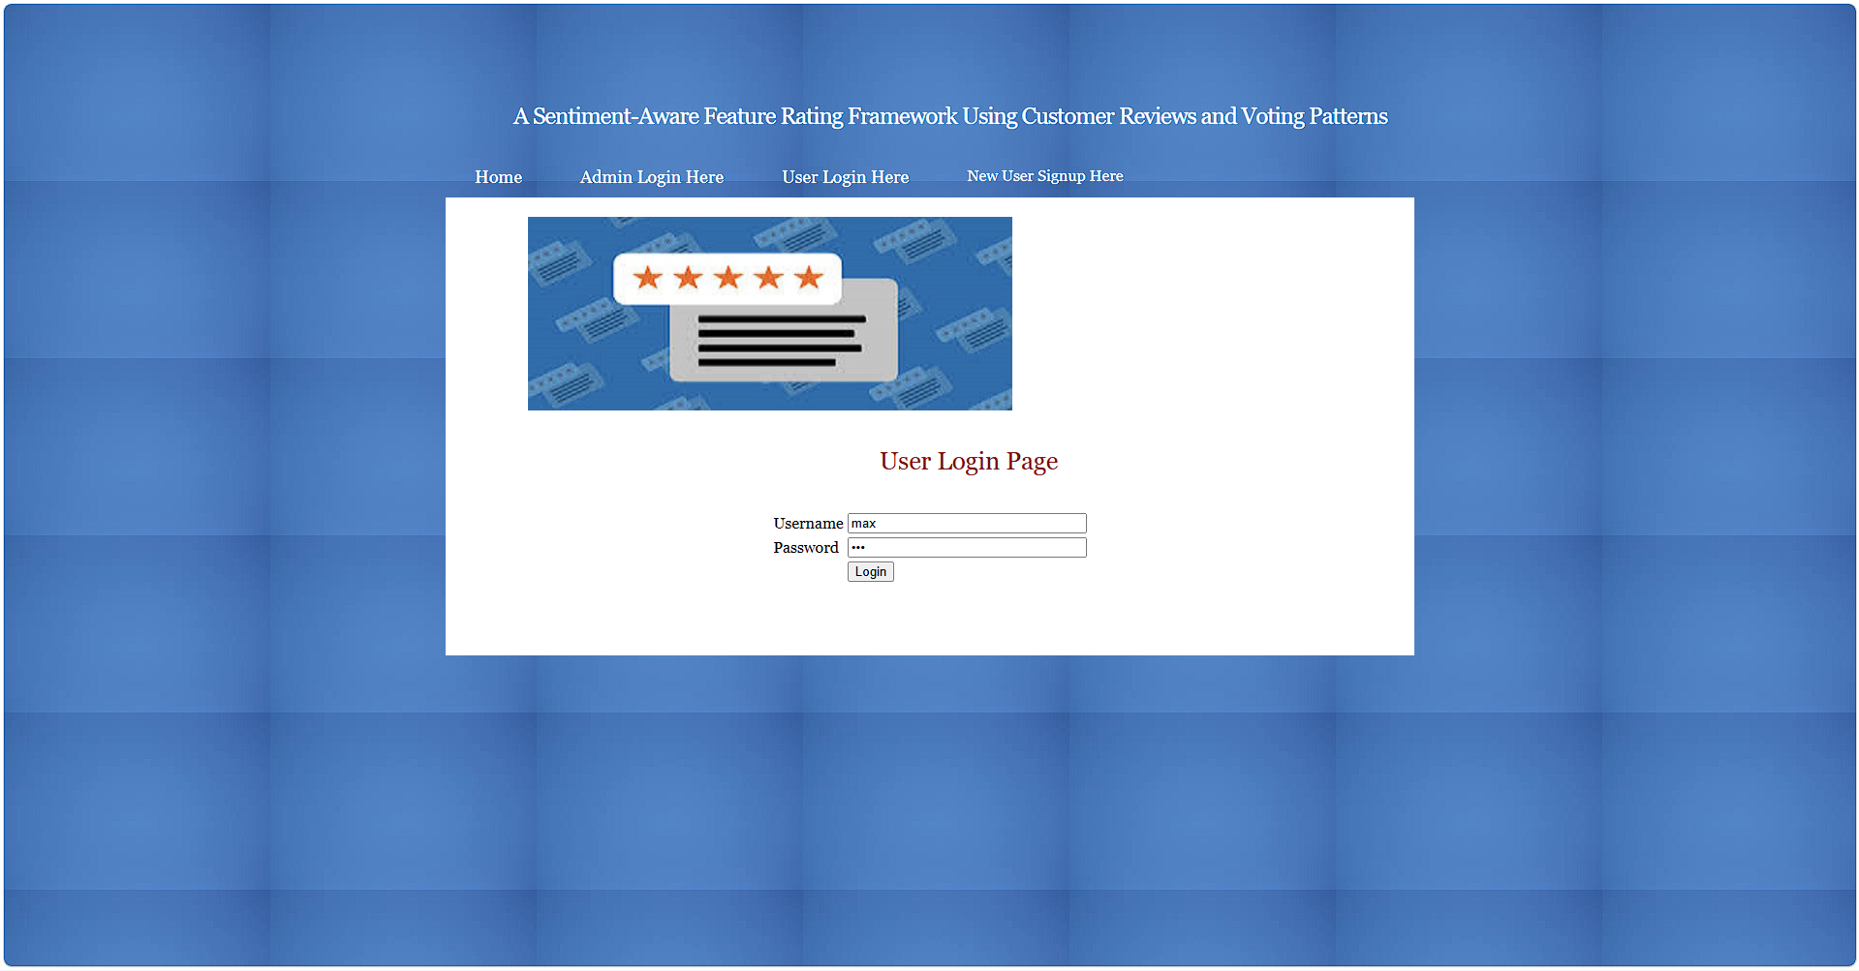
In above screen user is login and after login will get below page
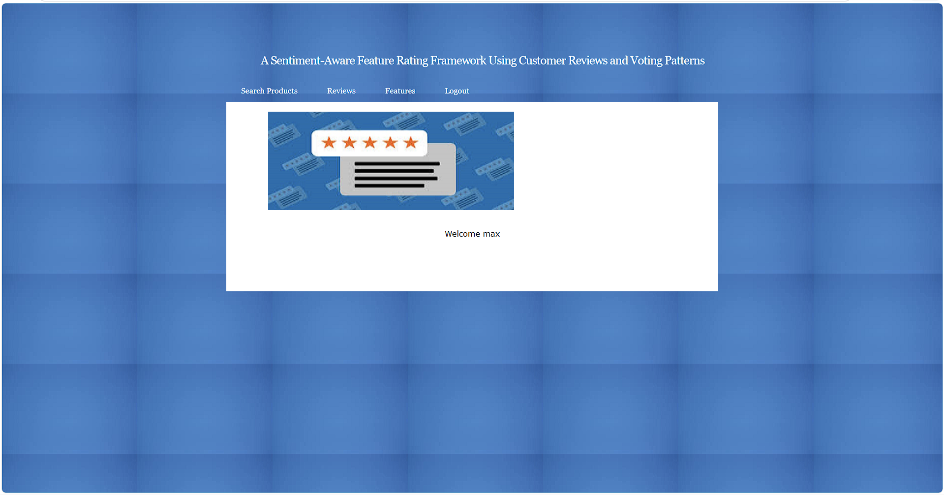
In above screen click on ‘Search Product’ link to get below page
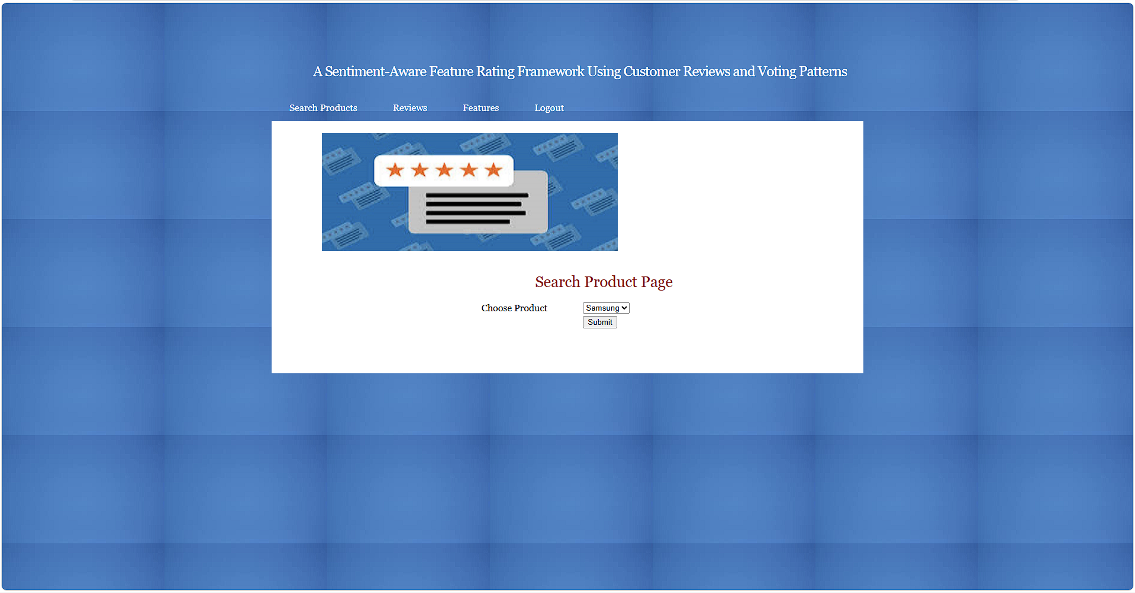
In above screen click on choose product name and then press button to get below page
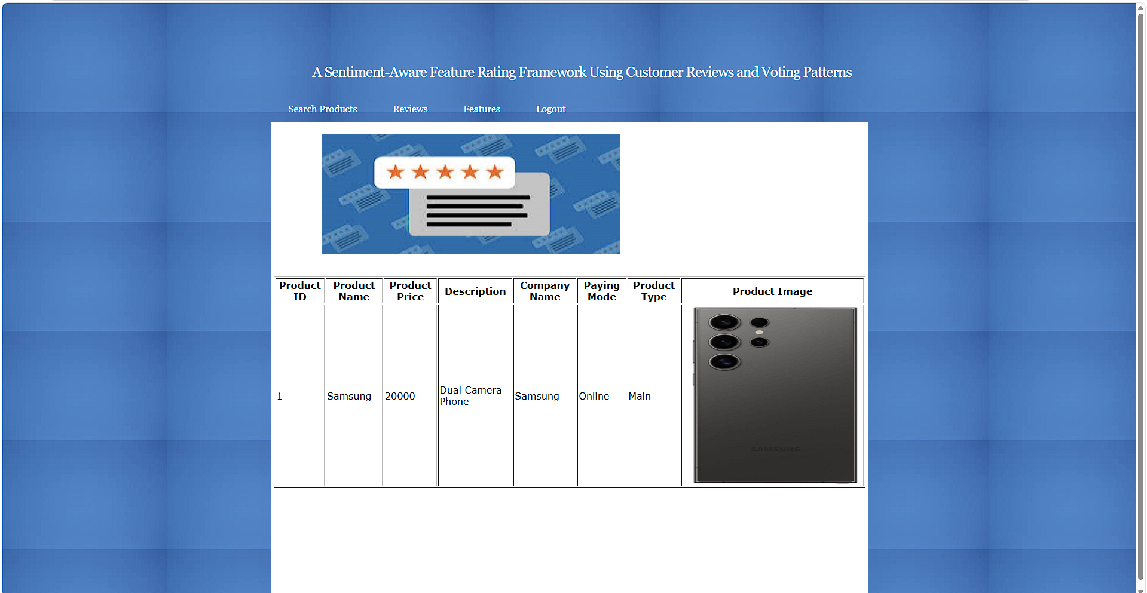
In above screen user can view all product details and now click on ‘Features’ link to add features level ratings and get below page
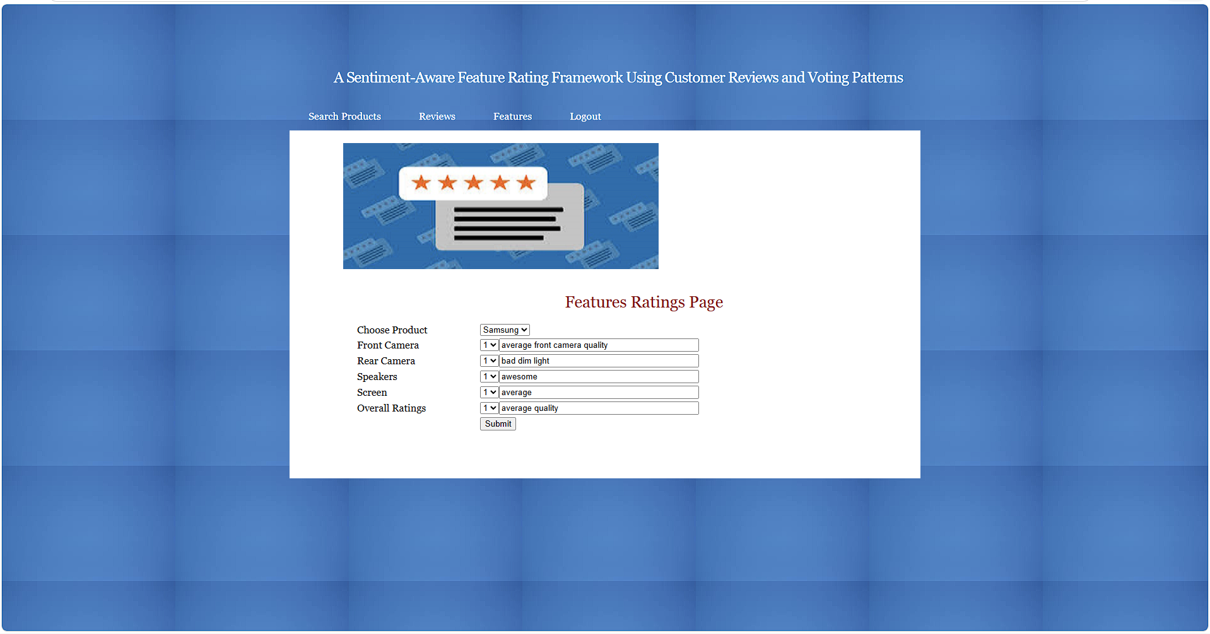
In above screen user giving ratings based on features and then press button to get below page
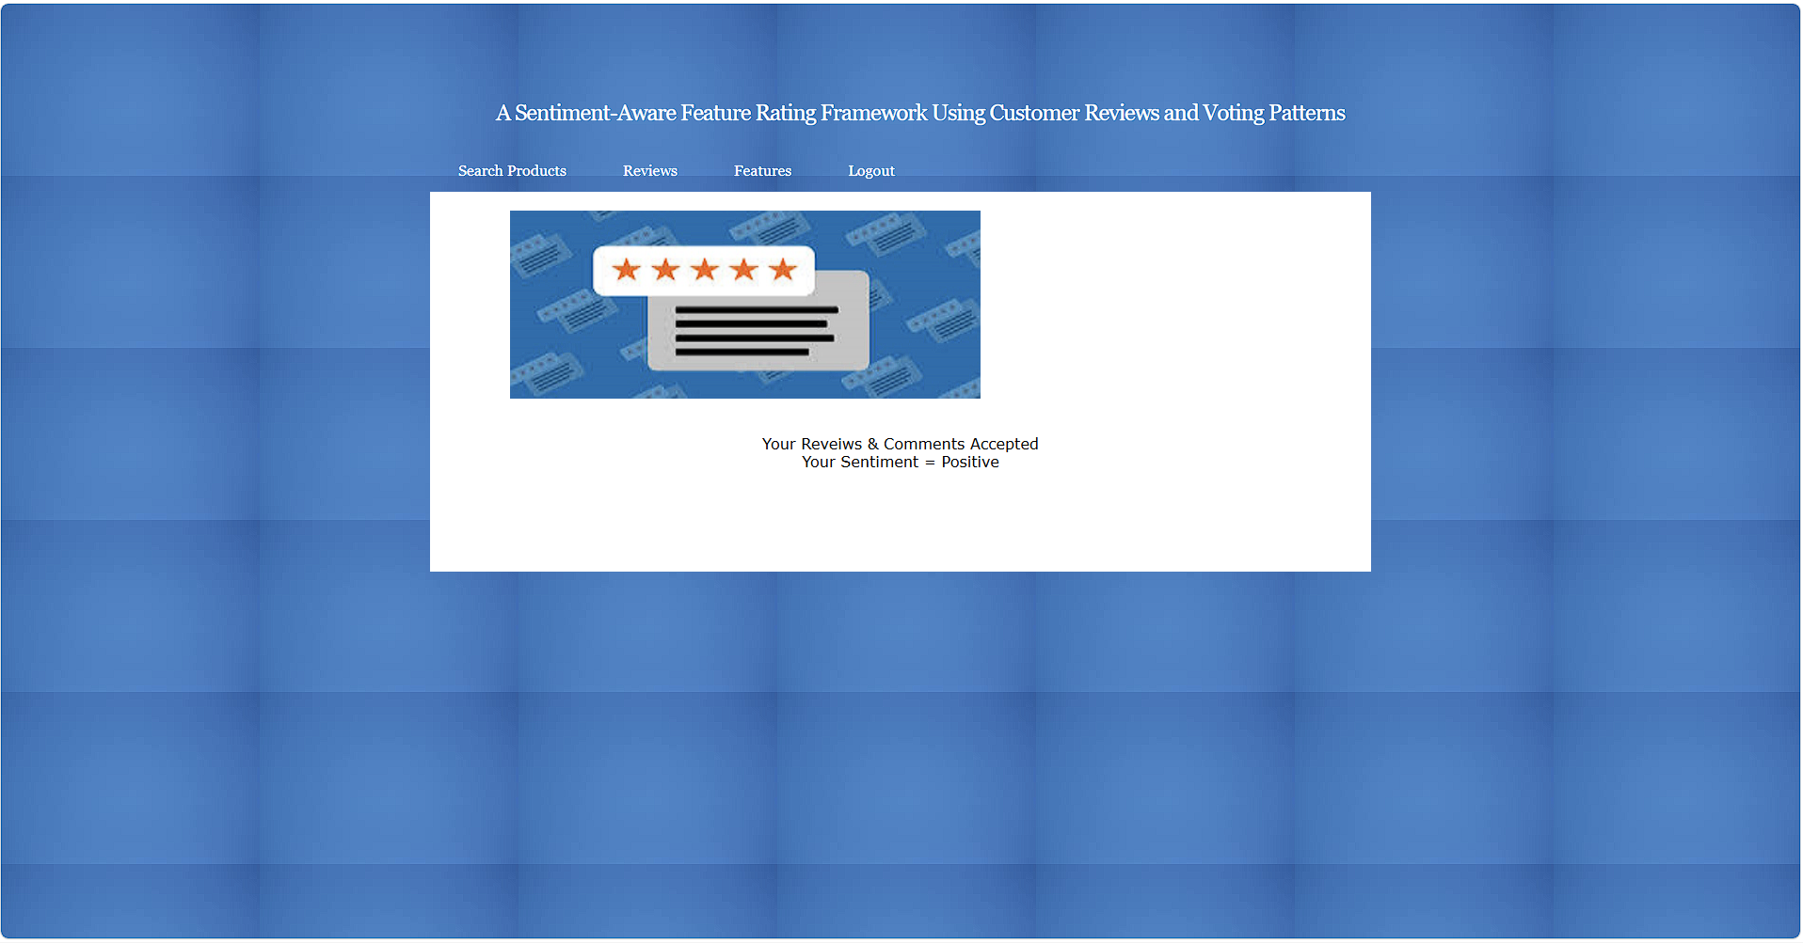
In above screen based on ratings user sentiment predicted as Negative and now click on ‘Reviews’ link to get below page
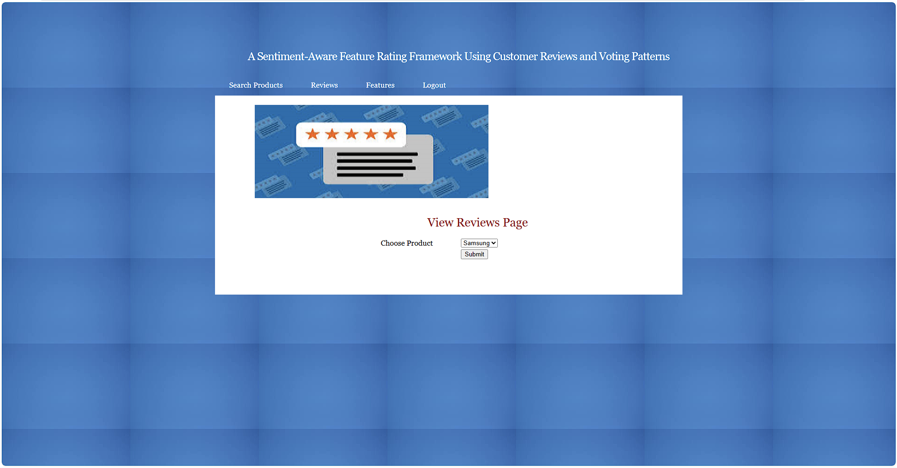
In above screen user can select product and then press button to view all reviews
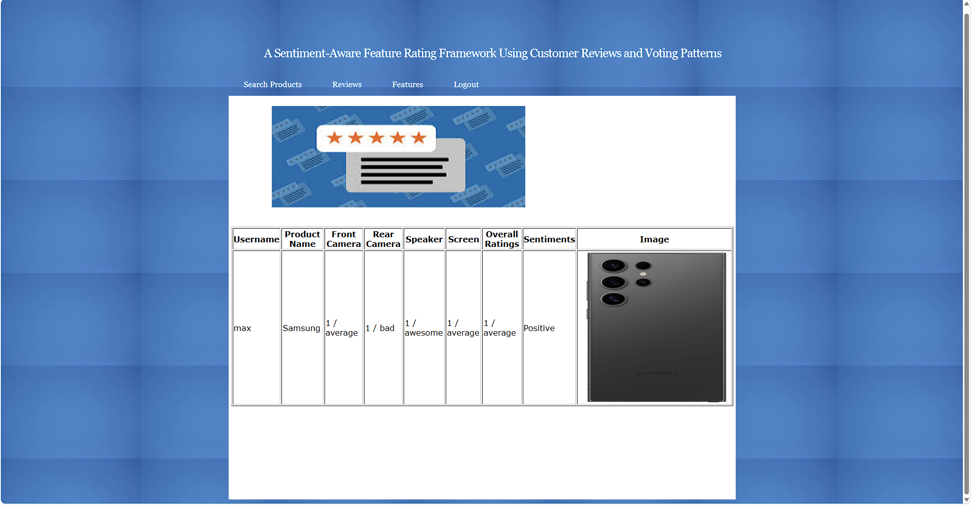
In above screen can see comments and ratings along with sentiments from selected product and now logout and login as admin
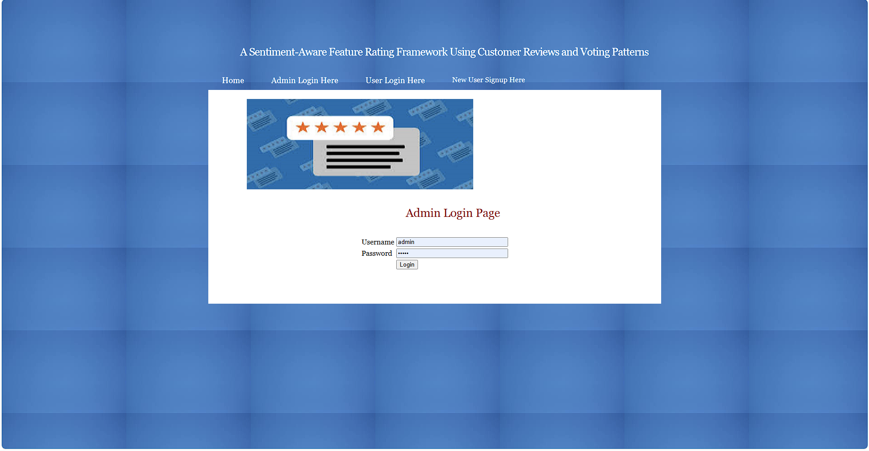
In above screen admin is login and then will get below page
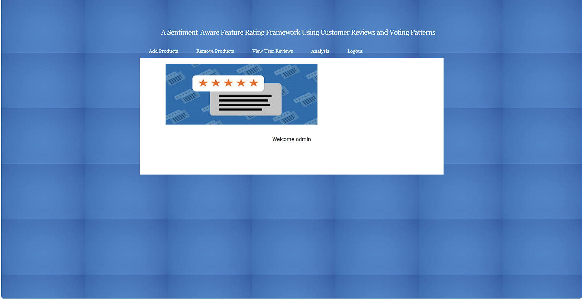
In above screen click on ‘Analysis’ link to views ratings of all products
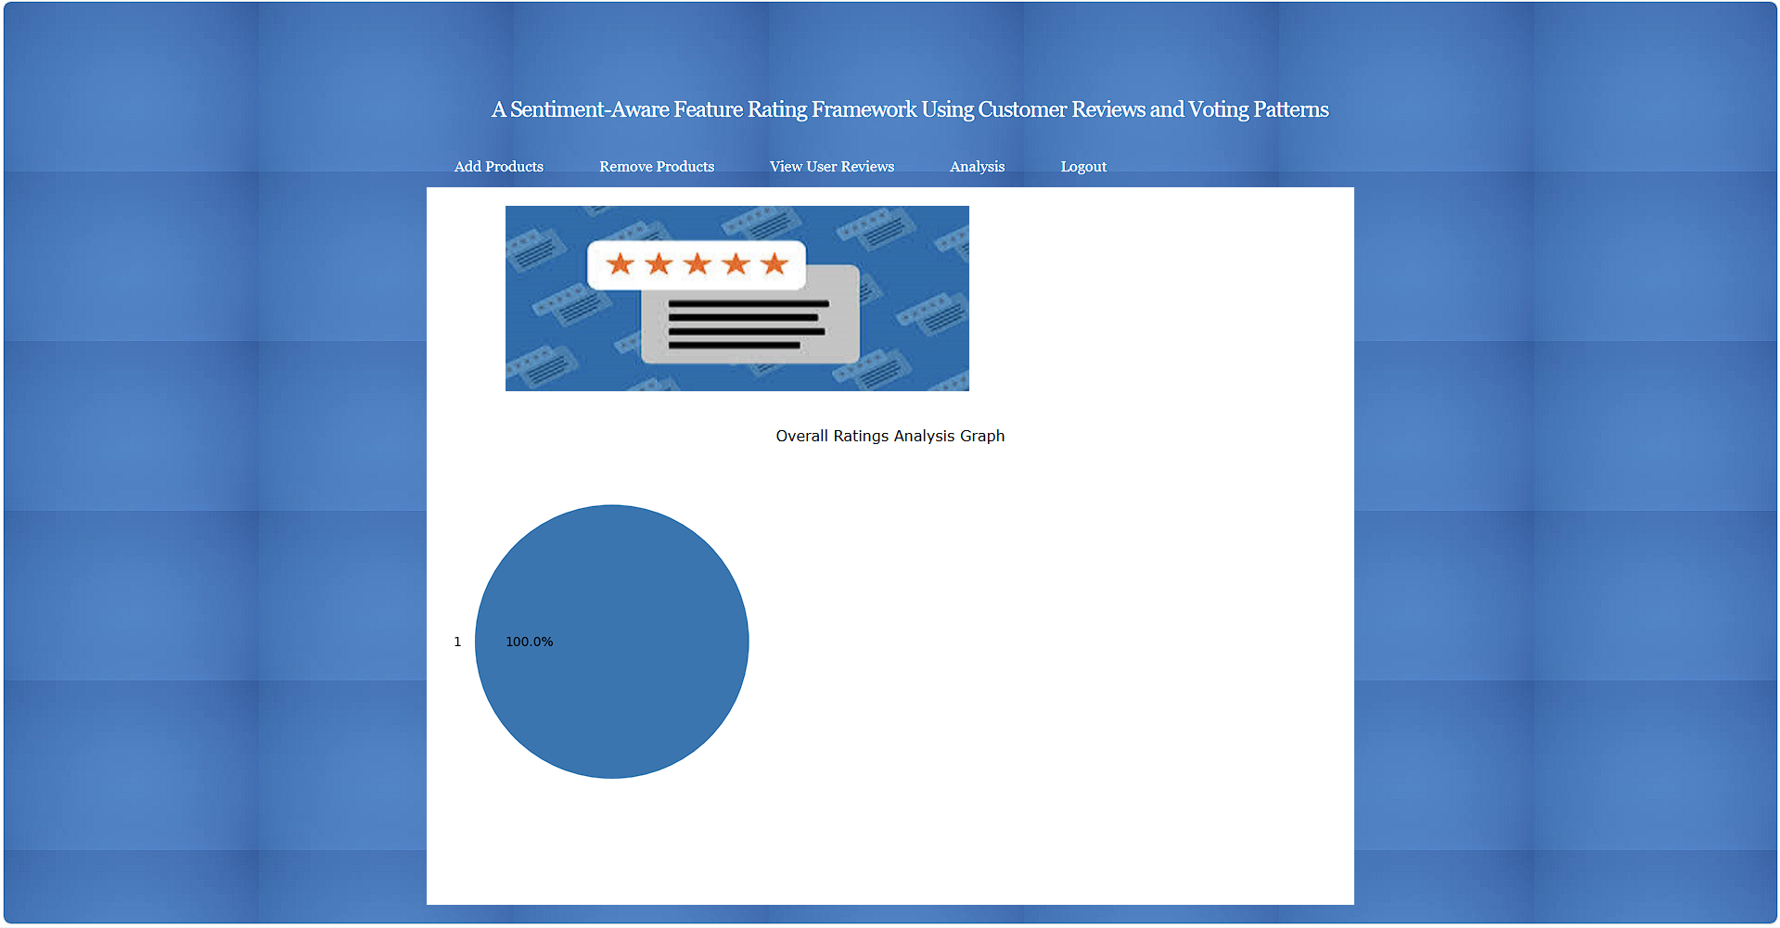
In above screen admin can view graph based analysis and now click on ‘User Reviews’ link to get below page
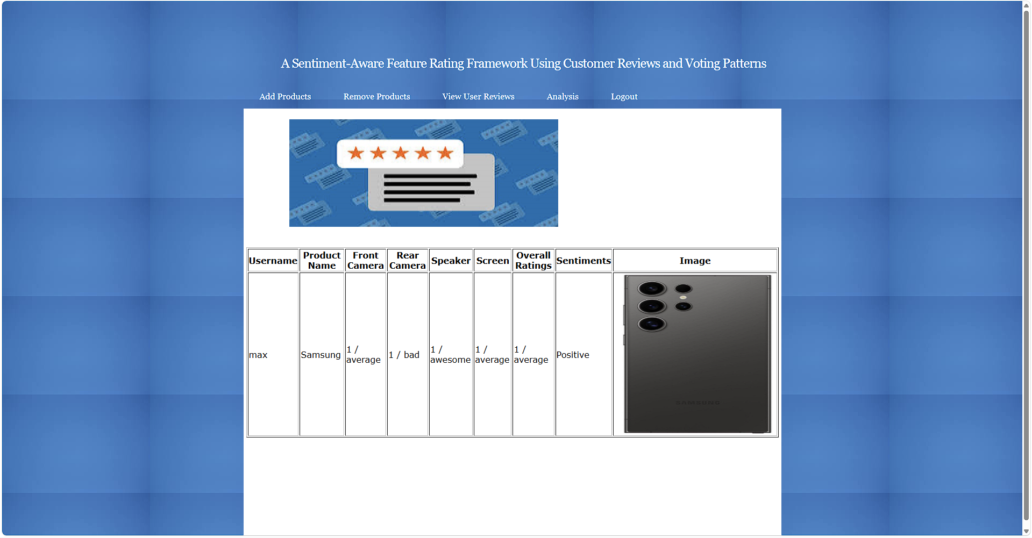
In above screen admin can view comments and ratings of all products from all users and now click on ‘Remove Product’ link to get below page
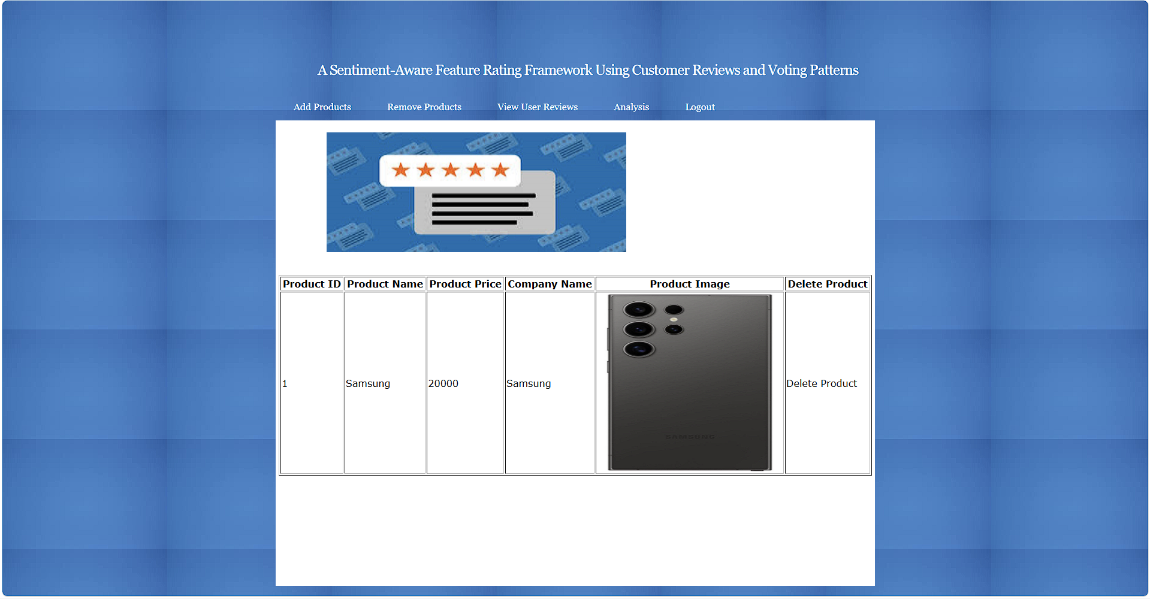
In above screen admin can click on ‘Delete Product’ link beside any product to delete product and get below page
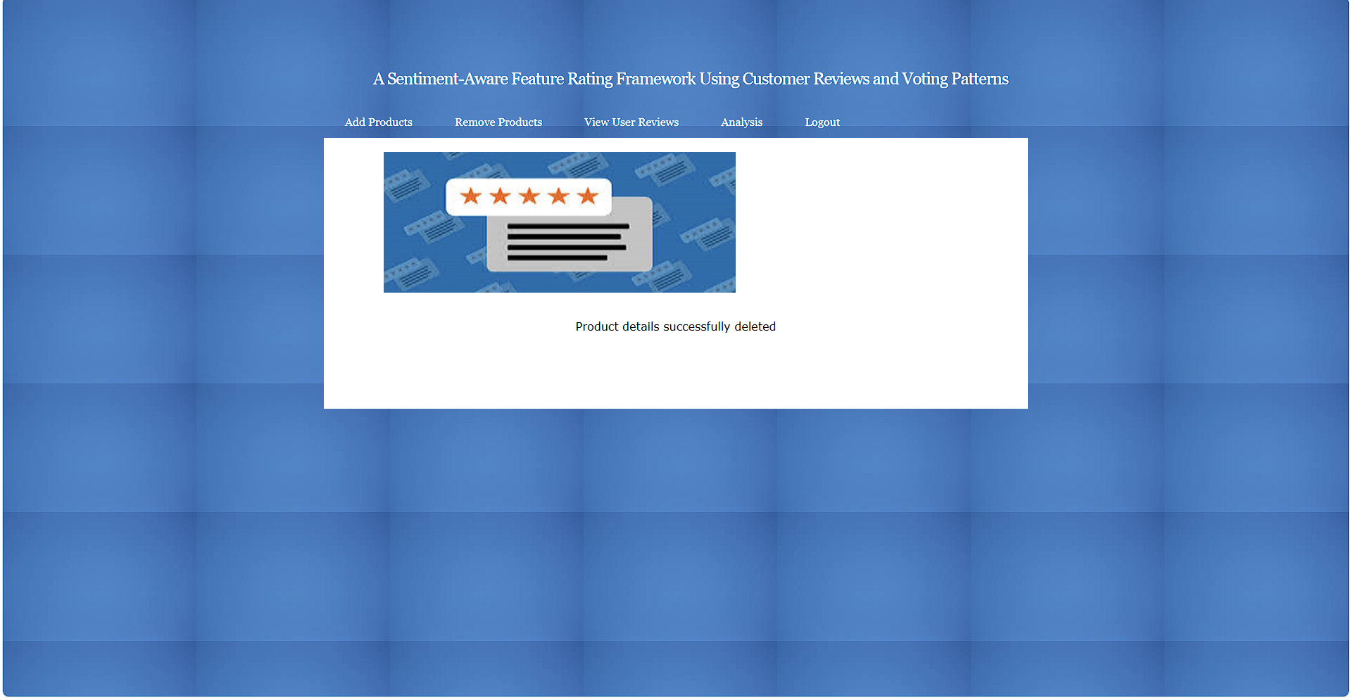
In above screen product details deleted.
Similarly by following above screen you can manage features level ratings for all products

